**Experiment No.1.9**

**Student Name:** Gaurav Kumar **UID:** 22MCC20177

**Branch:** MCA**–**CCD **Section/Group:** MCD-1/A

**Semester:** III **Date of Performance:** 10th Nov 23

**Subject Name:** DevOps Process Automation Lab **Subject Code:** 22CAP-745

1. **Aim/Overview of the practical:**
2. Create Manifest file in Puppet Server to install http.
3. Check it in Puppet Agent machine to start the services of http.
4. **Steps for practical: (a)**
5. Once Puppet-Master and Puppet-Slave connection is configured, Go to Puppet-Master machine.
6. Create a manifest file site.pp

sudo nano /etc/puppet/code/environments/production/manifests/site.pp

class webserver{

package { ‘apache2’: ensure => ‘installed’}

service { ‘apache2’: ensure => ‘running’,

enable => true,

require =>Package[‘apache2’]}

}

1. Then check the file by opening it.
2. Manifest file is created successfully.
3. Now restart the puppet-master services.

sudo systemctl restart puppet-master

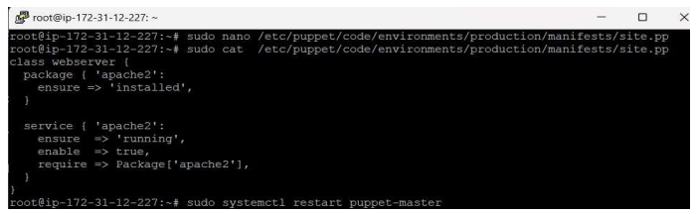

1. **Steps for practical: (b)**
   1. After creating the manifest file on Puppet-Master machine, Now go to Puppet-Slave machine for start services of http manifest file.
   2. Run sudo puppet agent –test.

* 1. Now to any web browser and type the ipv4 public address of your Puppet-Slave machine (in my case it is 62.0.32.34).

* 1. Manifest file services are configured and started successfully.